LEX Program to Count Vowels and Consonants
Aim :
To write a LEX program to read a sentence from an input file and count the number of vowels and consonants.

Pseudocode :
BEGIN
Open input.txt
If file cannot be opened
Display error message
STOP
End if
Initialize vowels = 0
Initialize consonants = 0
Read each character
If character is a vowel
Increment vowels
Else if character is an alphabet
Increment consonants
End if
Display vowels and consonants
Close the file
END

Code :

%{
#include <stdio.h>
int vowels = 0;
int consonants = 0;
%}
%%
[AEIOUaeiou] { vowels++; }
[A-Za-z] { consonants++; }
.|\n ;
%%
int yywrap(void) {
return 1;
}
int main(void) {
FILE *fp = fopen("input.txt", "r");
if (fp == NULL) {
printf("Error opening file\n");
return 1;
}
yyin = fp;
yylex();
printf("Number of vowels: %d\n", vowels);
printf("Number of consonants: %d\n", consonants);
fclose(fp);
return 0;
}

Output :
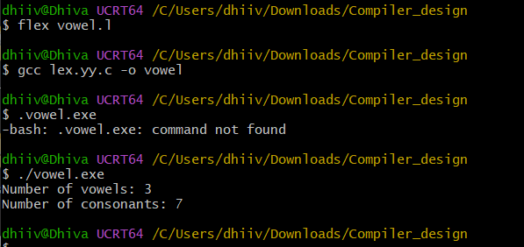

Result :

Thus, the LEX program was successfully executed to count the vowels and consonants in a sentence read from an input file.

